Sorting Hat

In this project you will make a Sorting Hat that will put you in one of the Hogwarts school houses based on what you say.

Your class will work together to teach the computer to recognise how students in different houses speak by giving it examples of dialogue from the books.

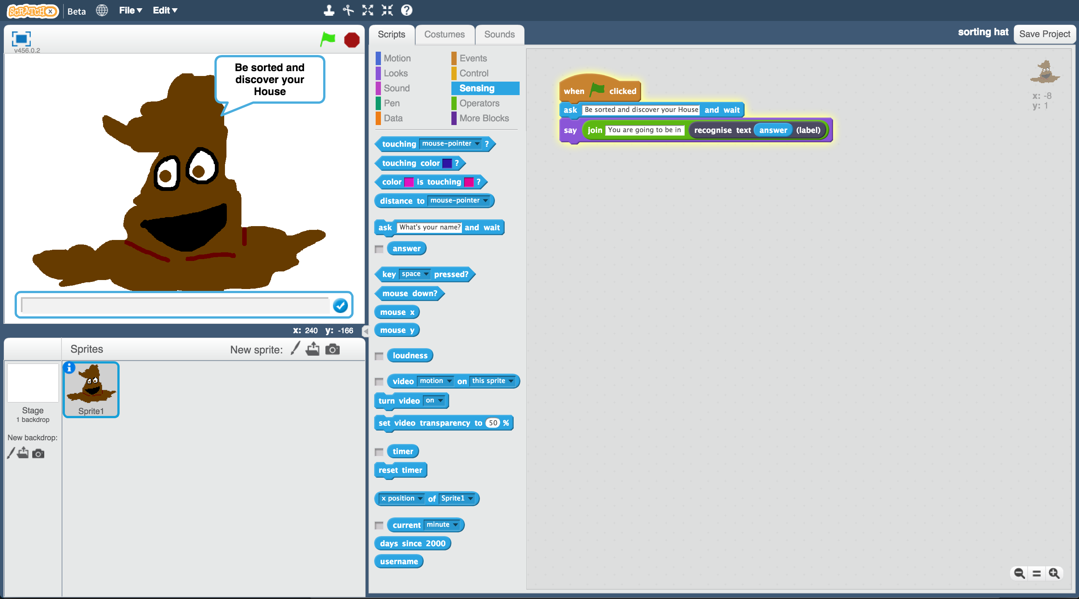

The idea for this project came from Ryan Anderson, who made a real-life sorting hat with his daughter!

<https://www.ibm.com/blogs/think/2016/06/watson-sorting-hat/>

**Teacher / Group leader instructions : Setup**

This version of the “Sorting Hat” activity will get your class to work together to train a single machine learning model. A version of this activity where students can work individually to each train their own machine learning can be downloaded from <https://machinelearningforkids.co.uk/worksheets>

**Objective:** Create a group project & prepare it for use by your class

1. Go to <https://machinelearningforkids.co.uk/> in a web browser
2. Login using your teacher username/password
3. Click on “**Projects**” in the top menu bar
4. Click on the “**+ Add a new project**” button
5. Create a project called “Sorting Hat”, set to recognise “**text**” and make sure you tick the “**Whole-class project**” checkbox  
   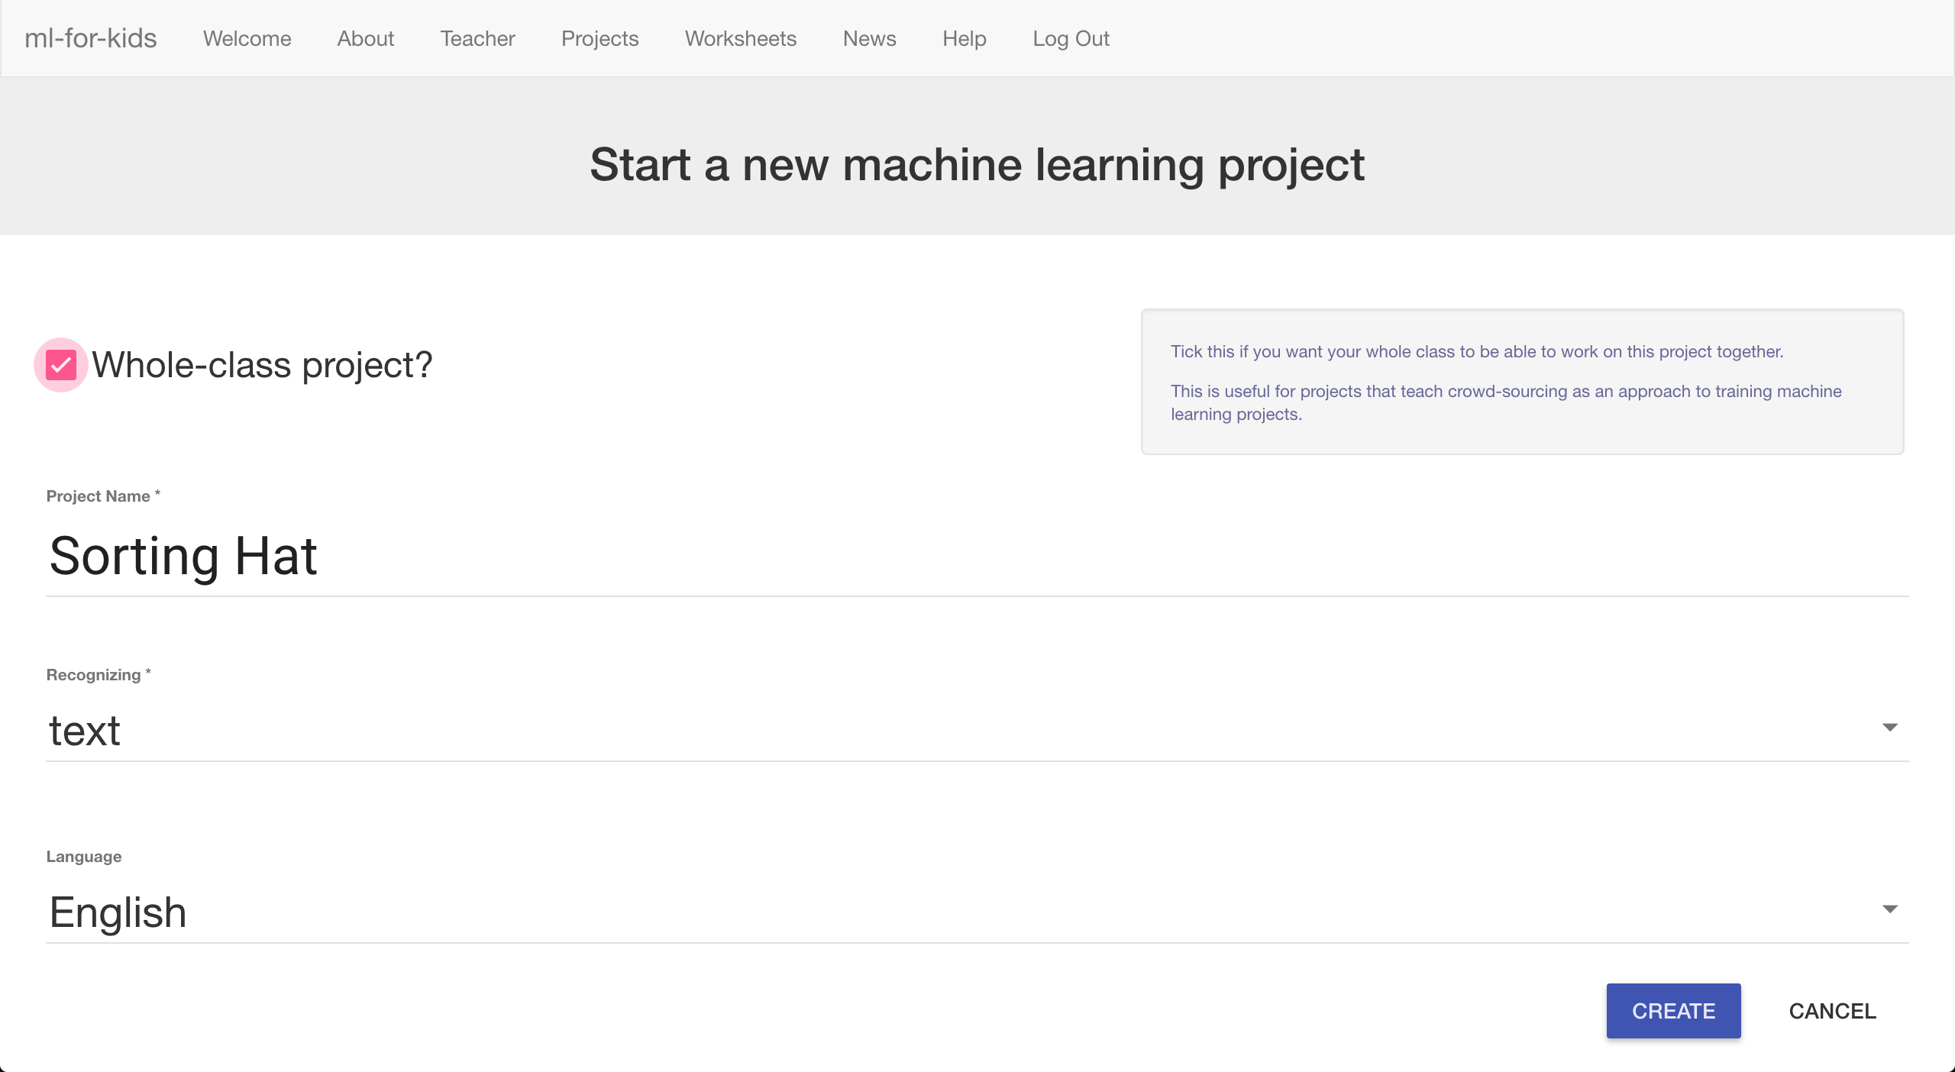
6. Click “**Create**”
7. Click on the “Sorting Hat” project in the list, and then click “**Train**”
8. Use the “**+ Add new label**” button to create four training buckets for Gryffindor, Hufflepuff, Ravenclaw and Slytherin  
   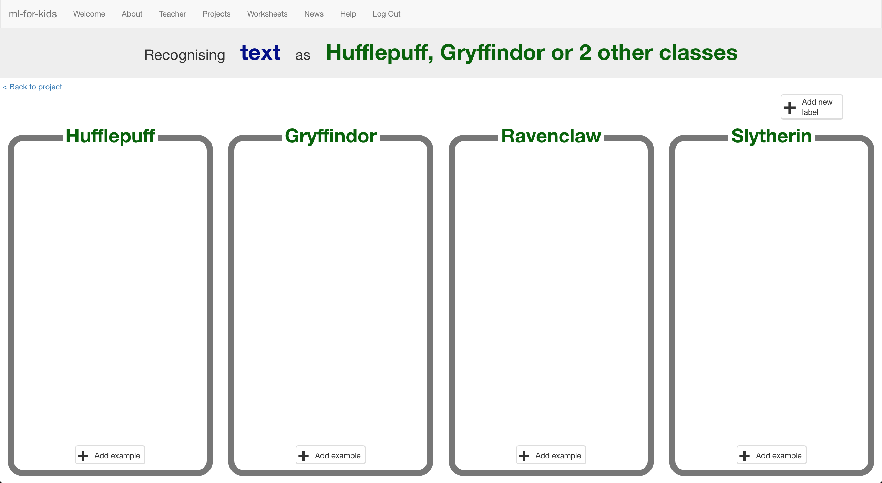

**Student instructions**

1. You will need some Harry Potter books for this project.   
   *Go to the school library!*
2. Go to <https://machinelearningforkids.co.uk/> in a web browser
3. Click on “**Get started**”
4. Click on “**Log In**” and type in your username and password  
   *If you don’t have a username, ask your teacher or group leader to create one for you.  
   If you can’t remember your username or password, ask your teacher or group leader to reset it for you.*
5. Click on “**Projects**” on the top menu bar
6. You should see a “Sorting Hat” project created by your teacher. Click on it.   
   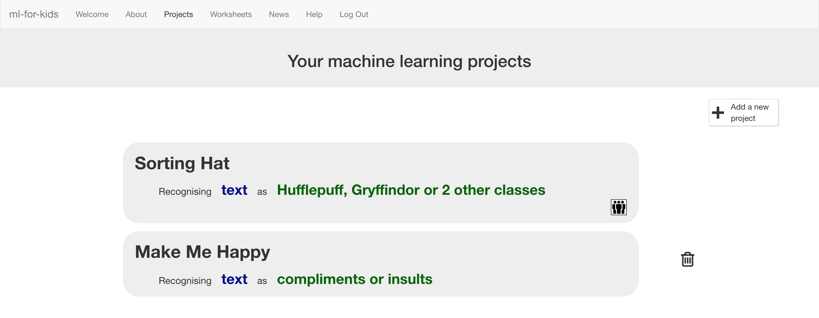
7. Click the “**Train**” button to start collecting examples of quotes to train the computer with.
8. Your teacher has prepared training buckets for each of the school houses in the Harry Potter stories.   
   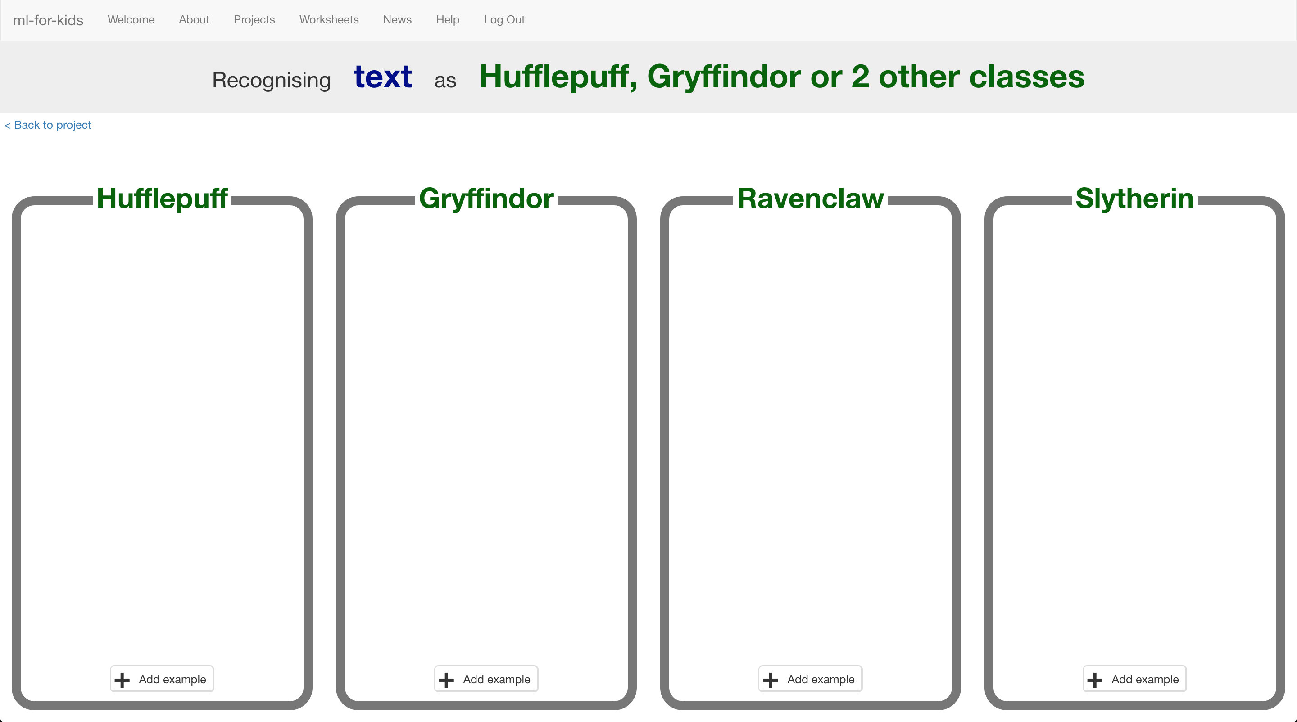

1. Click on the “+ **Add example**” button in the “Gryffindor” bucket. Find a quote by Harry Potter and type it into the box. Click “**Add**”  
   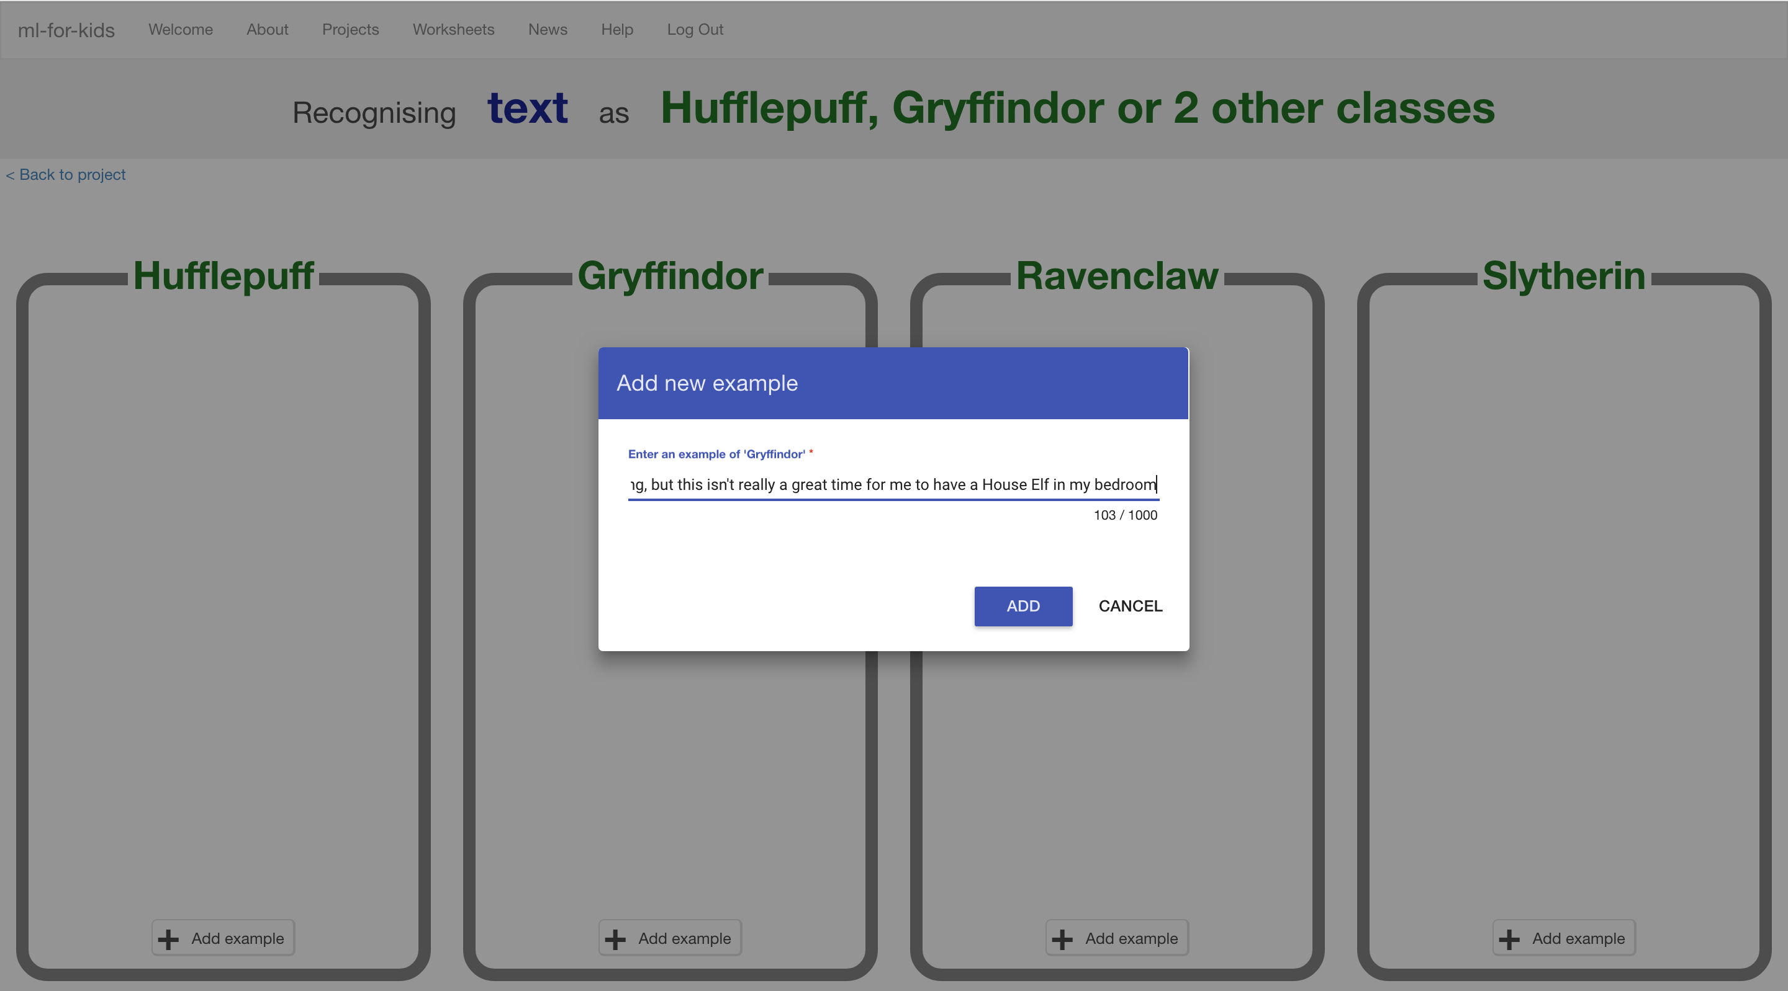
2. Add quotes for characters from each of the other three school houses in the same way, by clicking on “**+ Add example**”.
3. Keep going, collecting examples of quotes for each of the houses.   
   *If your computer screen is big enough, you can press Ctrl and – (the dash/minus key) at the same time to fit more on the screen.*   
   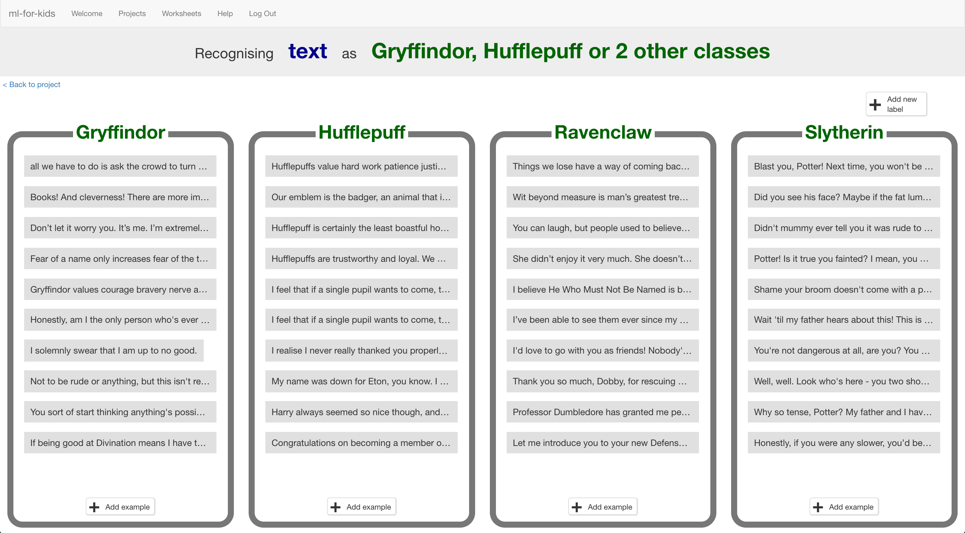
4. Your classmates will also be adding quotes to the same training buckets as you, but they won’t show up while you’ve got the page open.   
   *Refresh the page to see all the training so far from the whole class.*
5. Keep going until your class have collected enough examples.   
   **Don’t move past this step until your teacher tells you it’s time to move on.**

**Teacher / Group leader instructions : Train a ML model**

**Objective:** Monitor class progress & train a machine learning model

1. Click on “**Projects**” in the top menu bar
2. Click on the “Sorting Hat” project
3. Click on the “Learn & Test” button
4. Review the summary of the progress the class has made  
   *The more examples they collect, the better the model should perform but they need at least five examples of each house to be able to create a model at all.*  
   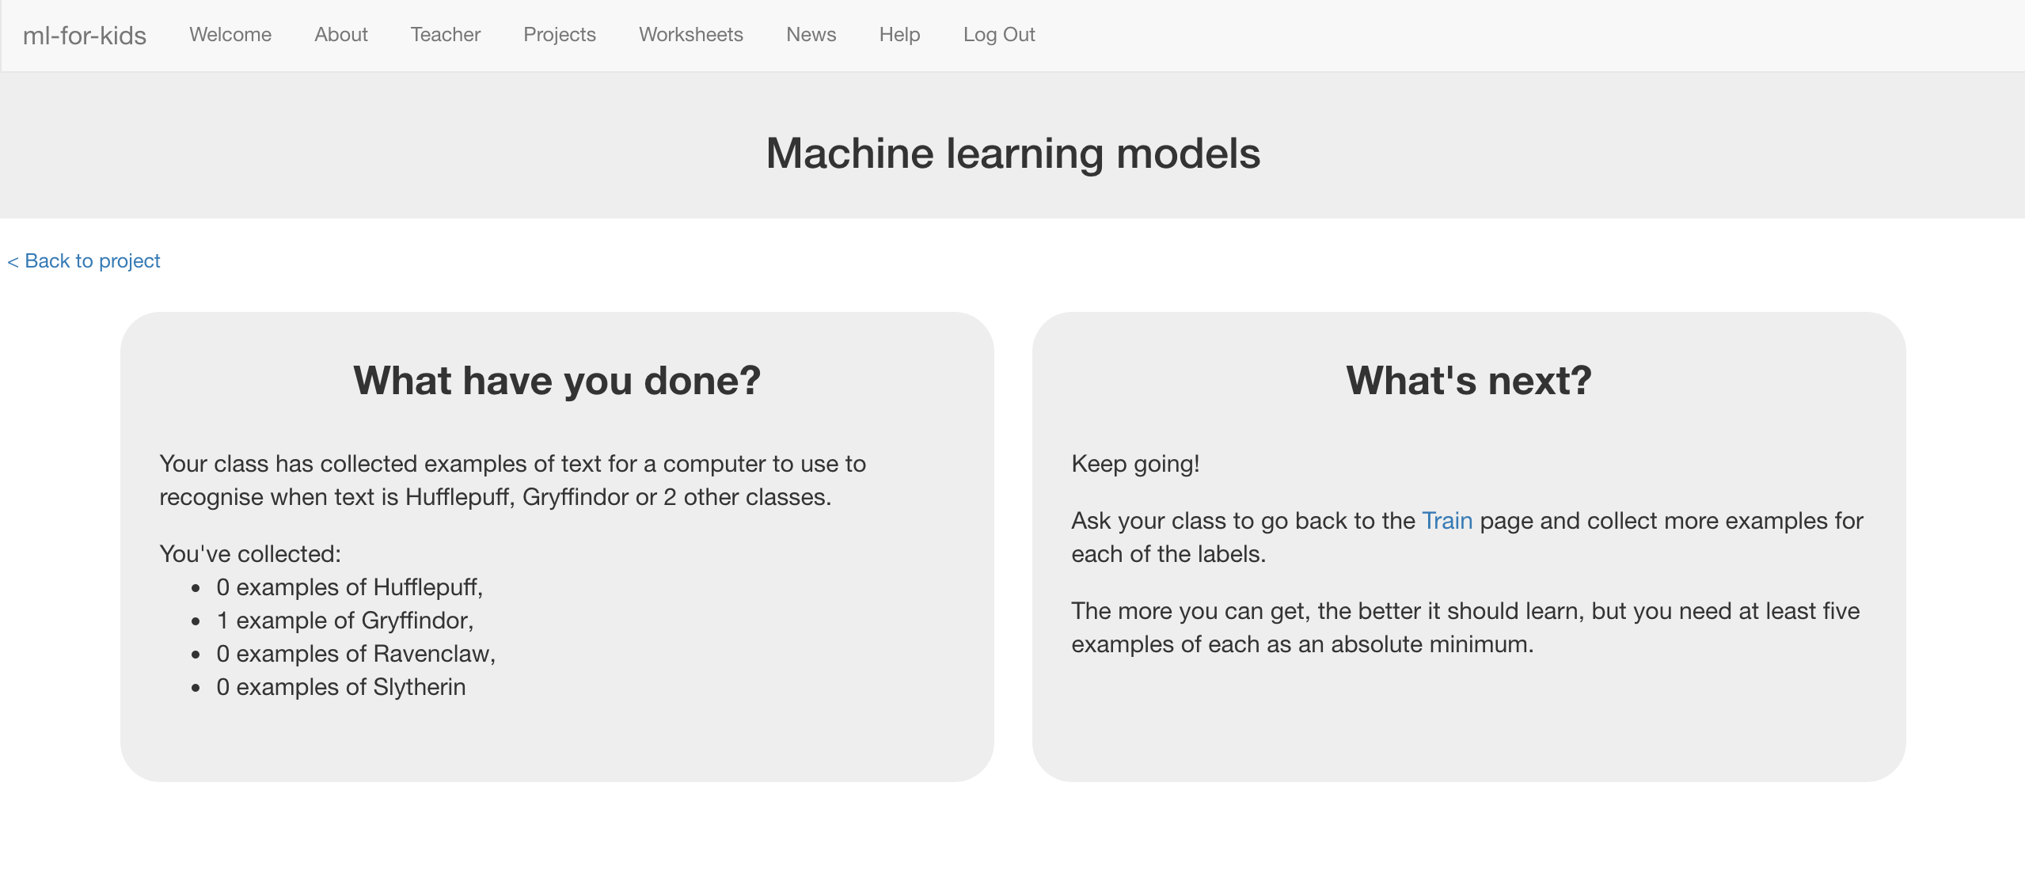
5. When you’re ready to proceed, click “**Train new machine learning model**” to train a new model using their examples.  
   *This may take a minute or two. The status on the page will change from “Training” to “Active” once it has finished.*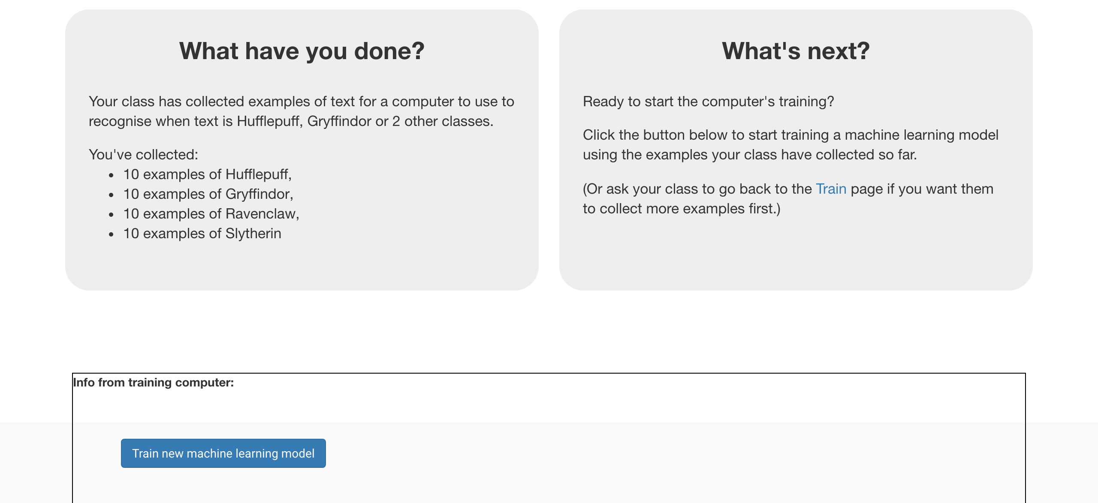
6. Once it is ready, you can tell the class it’s time to move on.

**Student instructions**

1. Click on the **“< Back to project**” link.
2. Your teacher has used the examples your class collected to train a machine learning model. To try it out click on “**Learn & Test**”
3. As long as the training has finished, a Test box will be displayed.   
   Try testing your machine learning model to see what the computer has learned.   
   *Test it with example quotes that you haven’t shown the computer before.   
   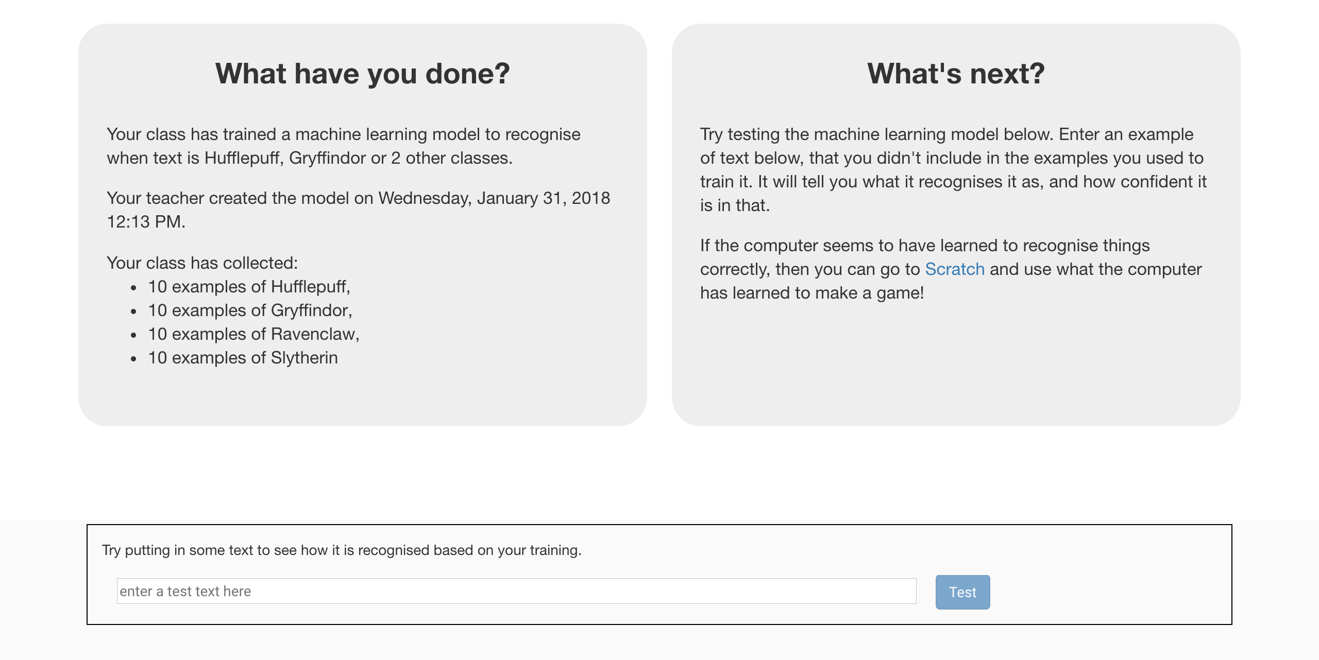*
4. Click the **“< Back to project**” link, then click the “**Scratch**” button.   
   *This page has instructions on how to use the new blocks in Scratch from your project.   
   Keep the page open if you need to check on how to use them.*

**What have you done so far?**

You’ve started to train a computer to recognise the use of language by different characters in the Harry Potter books.

These examples are being used to train a machine learning “model”.

This is called “supervised learning” because of the way you are supervising the computer’s training.

The computer will learn from patterns in the examples you’ve given it, such as the choice of words, and the way that sentences are structured.

These will be used to be able to make predictions about people not in the book, just like the Sorting Hat does.

Don’t worry if your model seems to get a lot wrong. With only a handful of examples of each house, the computer won’t have had very much to learn from yet. If you were doing this for real, you’d be collecting dozens or hundreds of examples for the computer to train on.

**Tips**

**More examples!**

The more examples you give it, the better the computer should get at recognising what the different school houses have in common.

**Try and be even**

Try and come up with roughly the same number of examples for each House.

This can be difficult – particularly for Hufflepuff! But try not to focus only on Gryffindor and Slytherin.

If you have a lot of examples for some houses, and not the others, the computer might learn that being in those houses is more likely than the others. That would probably affect the predictions that it makes.

**Quotes online**

If you’re struggling, or you don’t have a copy of a Harry Potter book available, try searching for quotes of your favourite characters online.

1. Click the “**Open in Scratch**” button at the bottom to launch the Scratch editor.   
   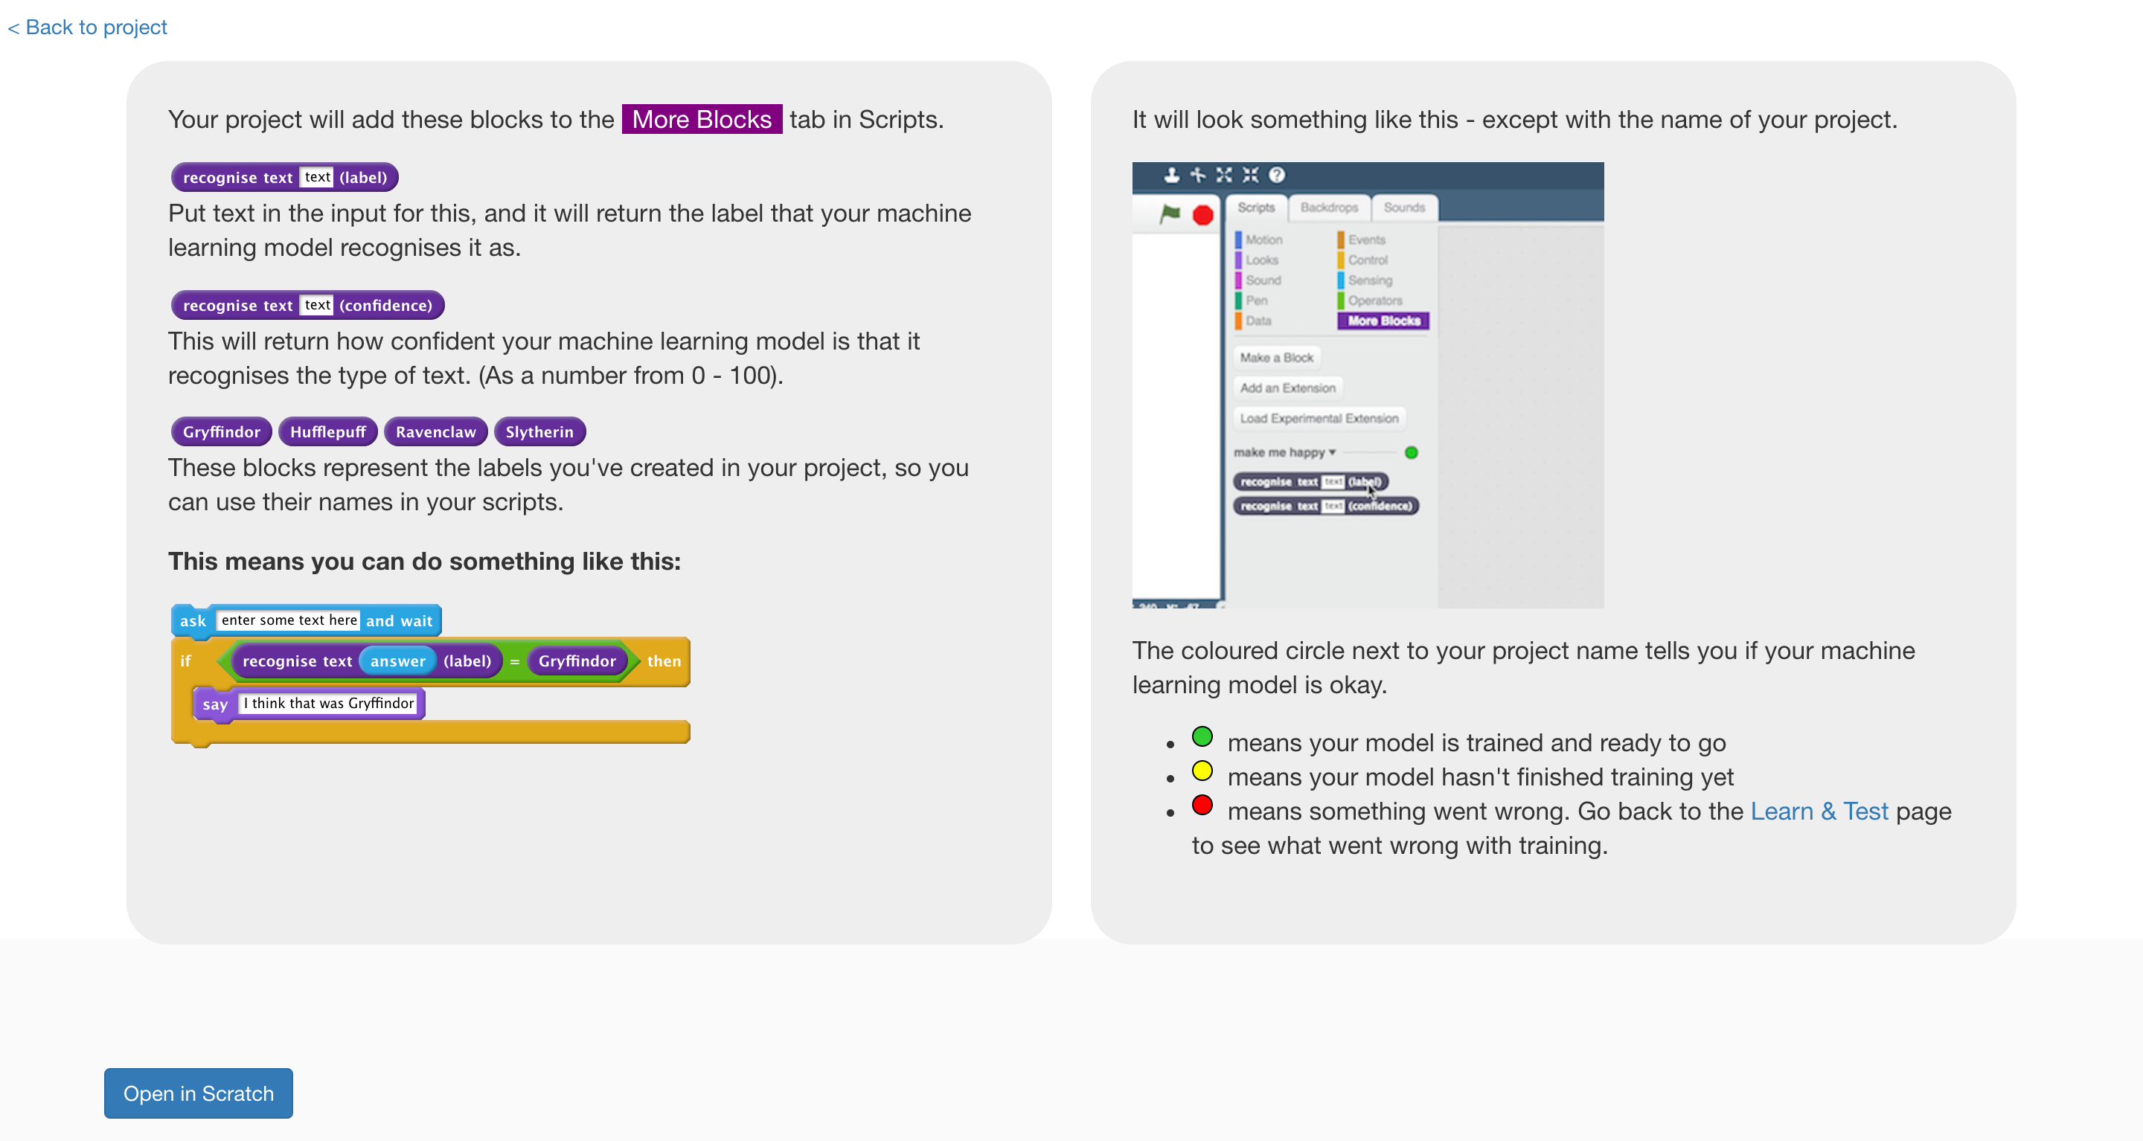
2. You should see new blocks in the “More blocks” section from your “sorting hat” project.  
   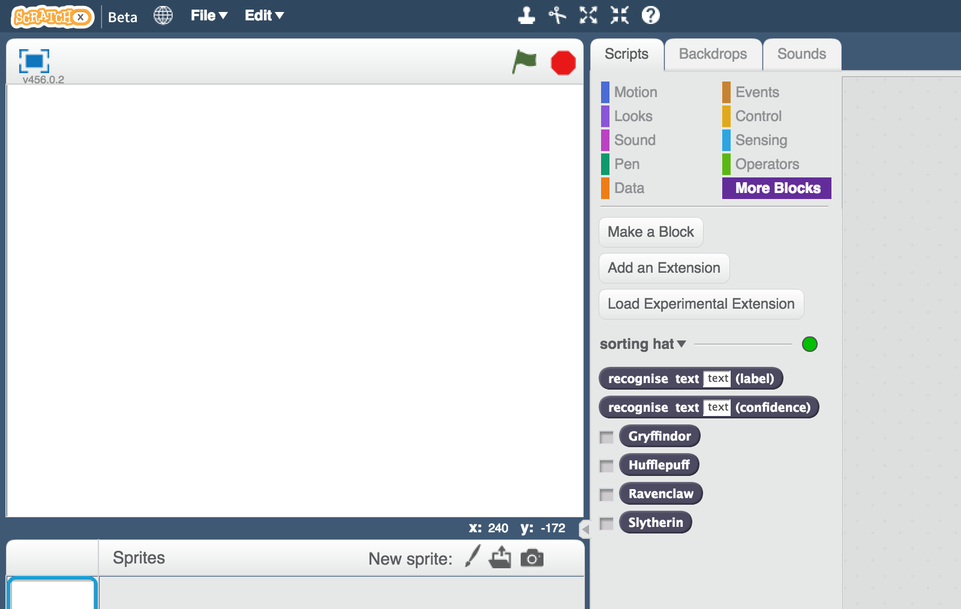
3. Create a new sprite by clicking on the paint brush icon next to “New sprite”, just below the white canvas.
4. Draw a Sorting Hat  
   *If you really don’t like drawing, you could find a picture of the Sorting Hat online, and use that instead. Click on the folder icon next to the paintbrush to import a sprite from a file.*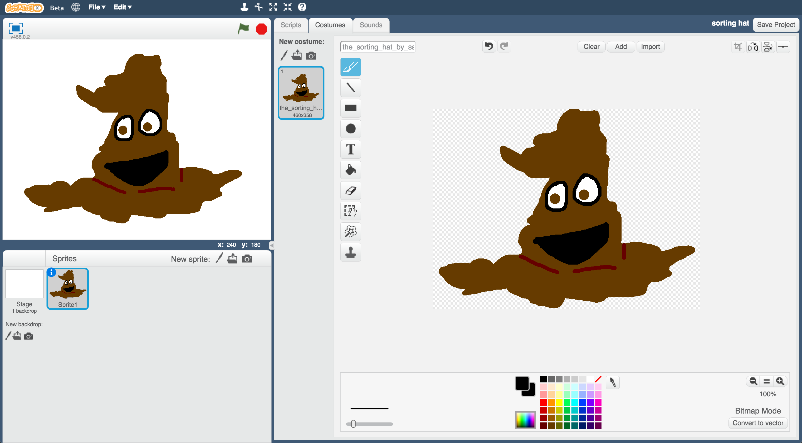
5. Click the “**Scripts**” tab, and enter the following script.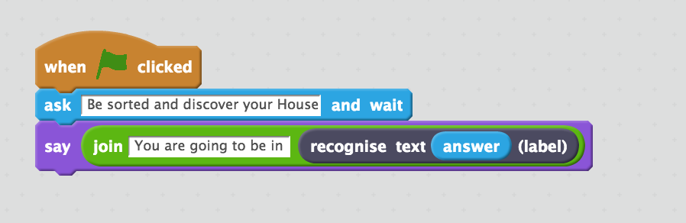

1. Save your project  
   *Click* ***File*** *->* ***Save* *Project***
2. Test your script!   
   Click on the **green flag**, and type in a message.  *Try typing in something that you would say, or something you have said and see which House the Sorting Hat would put you in!  
   Try it on your friends and see what House the Hat would put them in.*

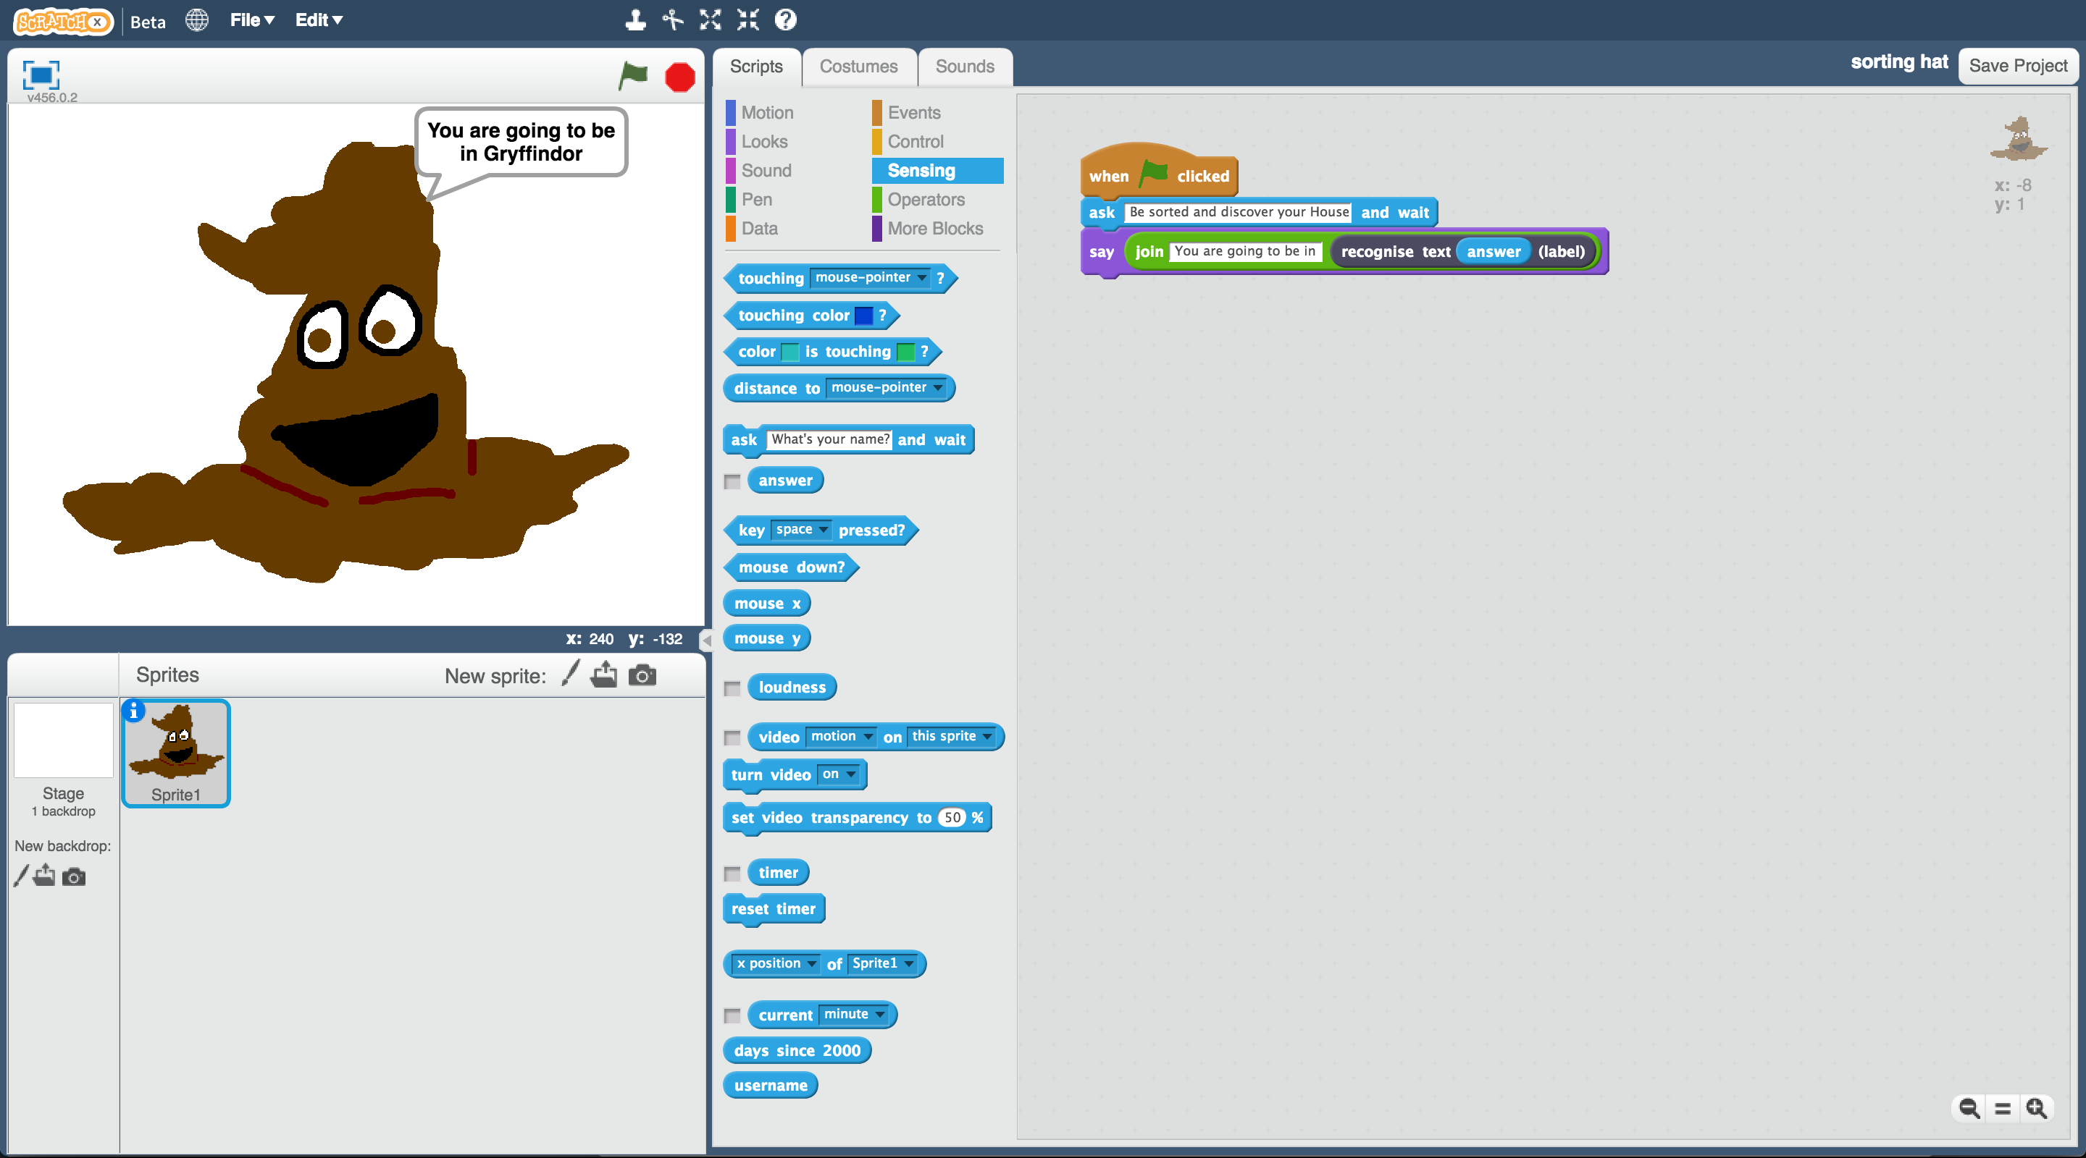

**What have you done?**

You’ve created a Scratch game version of the Harry Potter Sorting Hat, using machine learning.

You trained that machine learning model by collecting examples of quotes from characters, and telling the computer which House they are in.

You’ve seen that doing this well is difficult, and needs a lot of examples.

But even with a small number of examples, it’s fun to see the patterns that the computer learns, and how it tries to use that to recognise new text.

The idea for this project came from Ryan Anderson, who made a real-life sorting hat with his daughter!

Instead of typing messages to it, they also used speech-to-text so that they could actually talk to their Hat. Once they converted people’s voices into text, they trained a machine learning model to be able to recognise which House that should be, in a similar way to you have.

To see what the Hat looked like in action, check out their video at

<https://youtu.be/tSHoJoOOi9k>